Workshop Inspection

By: Group 5

To: Group 4

Code Quality

English: 16

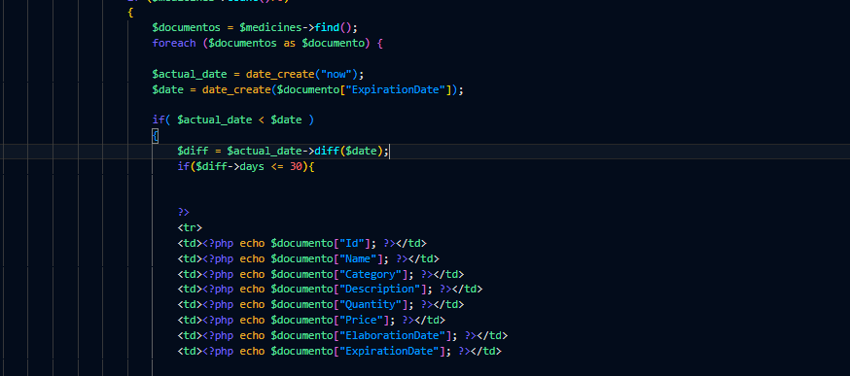

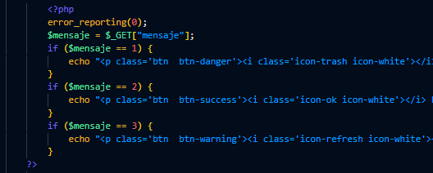

Camel case use or Snake Case use:20

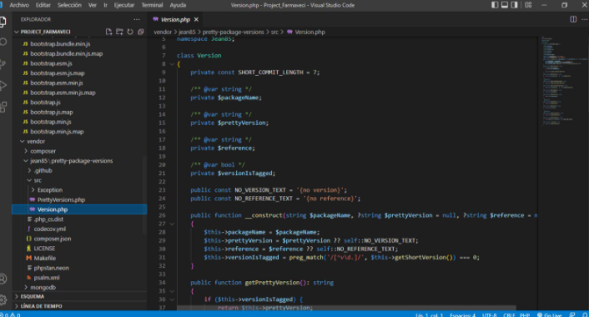

Horizontal and Vertical Formatting:20

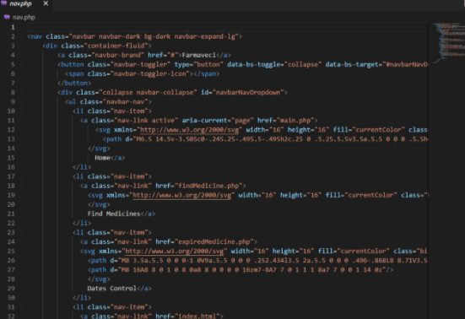

Visual Design Consistency: 14

Observation: missing visual design.

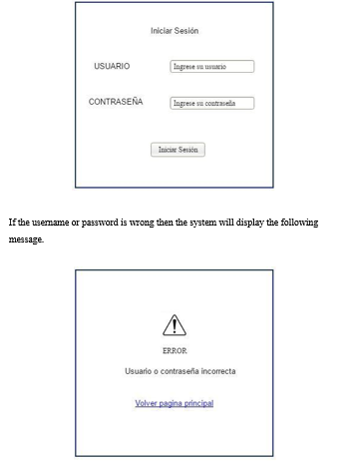

Uml Consistency : 18

Observation: Case of updating quantity is not unique and is with modify part.

Should modify just quantity.

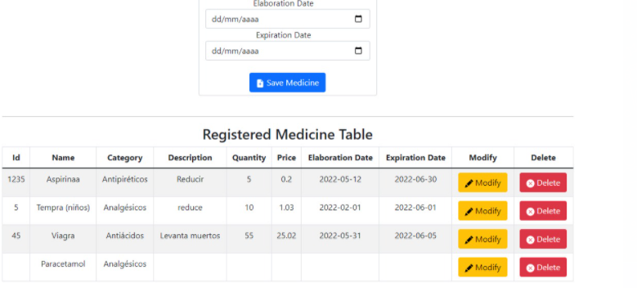

Execution from other 2 devices

Validation:20

Verification: 18

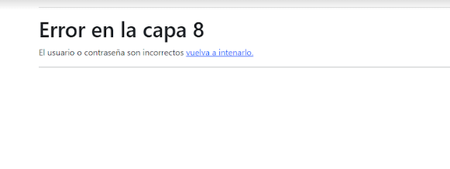

Navigation:16

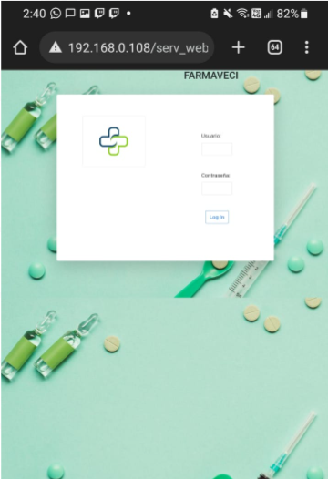

Main Page : 18

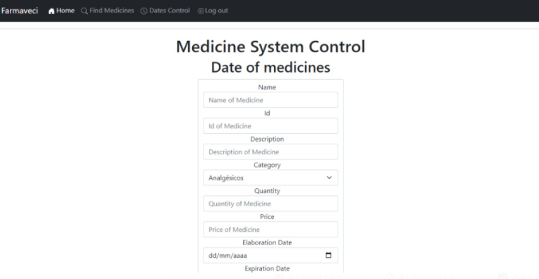

Query String:20

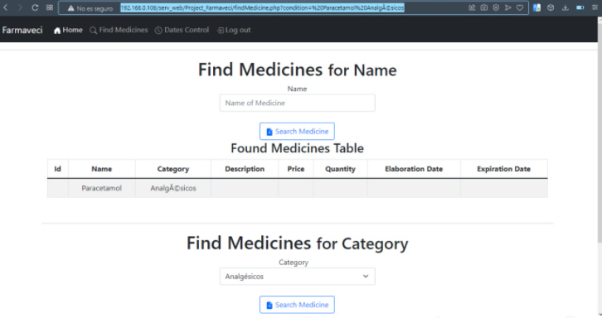

Git hub add:

